Sales Intelligence: Scrape the Market, Find the Right People, Know What to Pitch

Project Overview
The proposed Sales Intelligence solution is a B2B sales intelligence and data enrichment platform designed to help businesses identify potential companies, find the relevant decision-makers within those companies, obtain verified contact information, and determine what products or services to pitch to each prospect.
The system essentially converts raw market data into sales-ready prospects by combining web/LinkedIn data scraping, company and employee enrichment, contact verification, and AI-generated sales recommendations.

Problem Being Solved
Traditional B2B prospecting often requires sales teams to manually:
- Identify companies within a target market.
- Research company information.
- Find relevant employees or decision-makers.
- Search for their contact information.
- Determine whether the company is a suitable prospect.
- Research what product or service would be relevant to that company.
- Create an appropriate sales pitch.
This process is time-consuming and can result in outdated or incomplete prospect databases.
The system attempts to automate this process by continuously collecting and enriching market information instead of relying entirely on static contact lists.

How the System Works
The platform follows a four-stage process that transforms a broad target market or raw prospect list into enriched, sales-ready opportunities.
Ingest → Enrich → AI Analysis → Reach Out

01. Ingest — Identify the Target Market
The process begins with defining the companies the sales team wants to target. The platform supports two entry points:
- CSV Upload: Import an existing list of companies or prospects, including any available company or contact information.
- Market Discovery: Specify a target market or segment and use web and LinkedIn scraping to discover relevant companies and employees.
The output of this stage is a raw prospect pool that can be processed and enriched further.

2. Enrich
The platform converts basic company records into detailed company and contact profiles.
Company Enrichment captures information such as:
- Firmographic and company information
- Industry and market segment
- Employee information
- Relevant business and market signals
Contact Enrichment identifies relevant people within each organization — such as founders, executives, decision-makers, or functional leaders — and associates them with available email addresses and phone numbers.
A verification layer is applied to contact information to improve its accuracy and usability for outreach.
Output:
A consolidated prospect profile combining Company Intelligence + Relevant Contacts + Verified Contact Information.

3. AI Advises What to Pitch
The enriched prospect profile is then analyzed by the AI recommendation layer.
Rather than stopping at “here is a company and its contact details,” the system attempts to determine why the company may be relevant and how it could be approached.
For each prospect, the AI generates:
Sales Question | AI Output
What to pitch? | Potentially relevant product or service
Why this company? | Business context, signals, or characteristics supporting the opportunity
How to approach? | Suggested sales angle and conversation talking points
This transforms the output from a conventional prospect list into contextualized sales intelligence that can help a salesperson prepare for the conversation.
Output:
Prospect + Relevant Contact + Why It Matters + What to Pitch + Talking Points

4. Reach Out
Once the prospect has been enriched and analyzed, the resulting information can be used for outreach through multiple channels:
WhatsApp · Phone · Email
The enriched prospect data and AI-generated recommendations can also be passed into existing CRM, calling, messaging, or sales automation workflows, or exported for use in other systems.
This creates a connected flow from prospect discovery → research → sales intelligence → outreach, reducing the amount of manual research required before a salesperson can engage with a prospect.

Technical Engine Behind the Workflow
Component | What it does | Sales value
Web / LinkedIn Scraping | Collects fresh company, employee and market information | Keeps prospect data current
Data Enrichment Pipeline | Builds detailed company + employee profiles | Gives sales teams more context before outreach
Contact Verification | Verifies relevant emails and phone numbers | Improves contactability and reduces wasted outreach
AI Recommendation Layer | Analyzes the prospect and generates pitch angles | Helps salespeople understand what to say and why
Data Processing Pipeline | Handles CSV ingestion, deduplication, enrichment and export | Makes large-scale prospecting operationally manageable
Multi-Channel Integration | Pushes prospects into WhatsApp, calling and email workflows | Converts research directly into outreach
Credit-Based Usage Model | Tracks enrichment activity through credits | Enables usage-based monetization instead of traditional per-seat pricing

Architecture
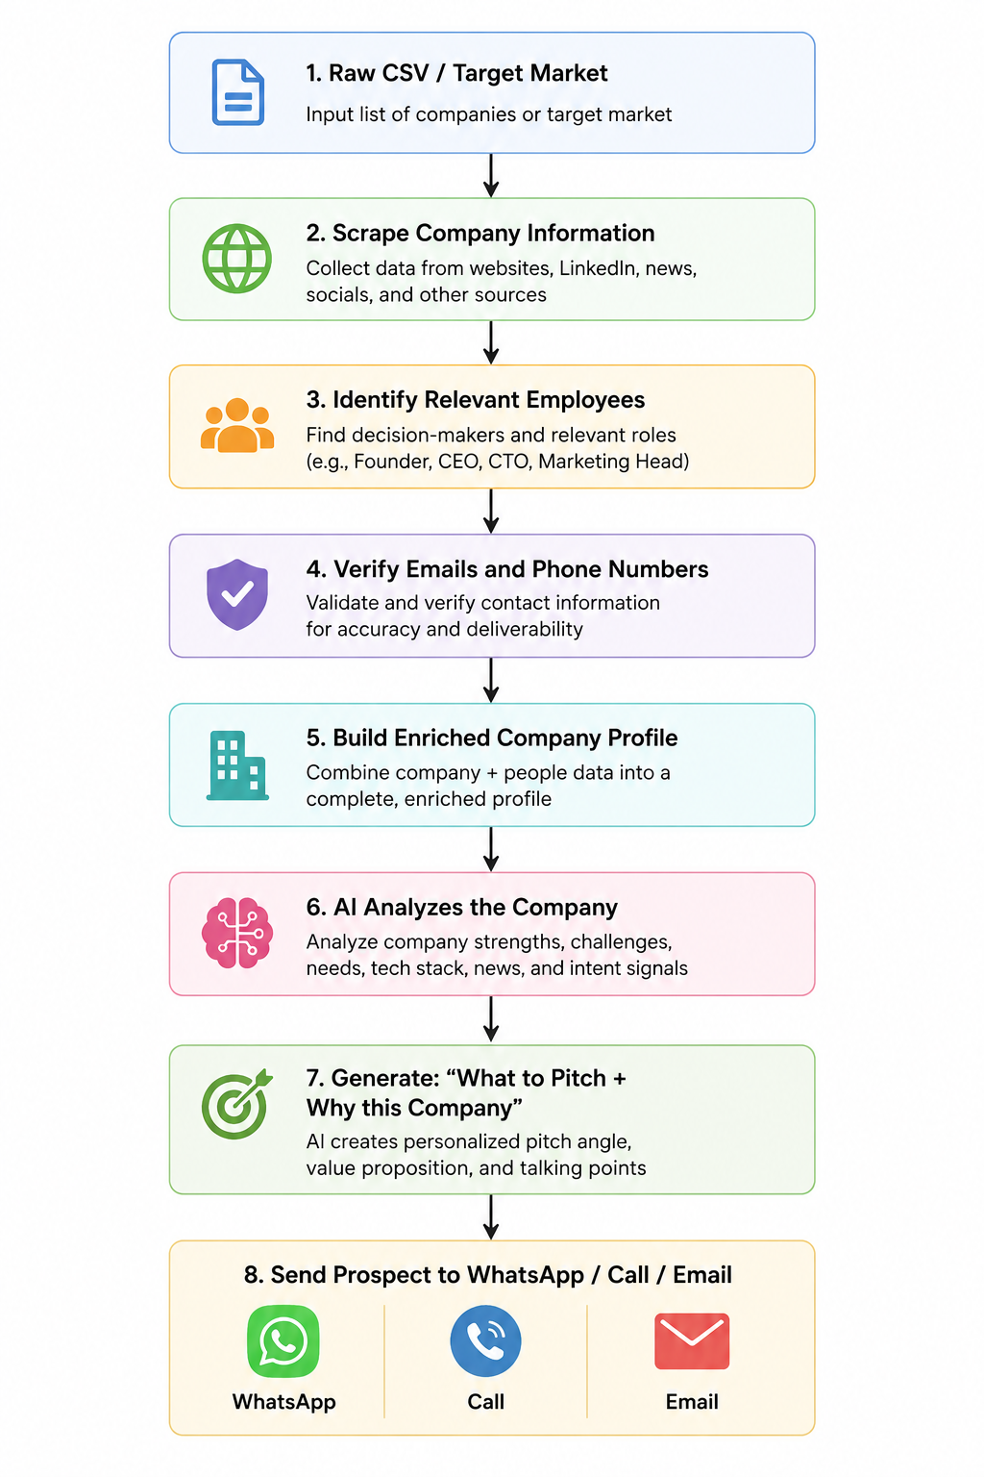

Business Value
The main business value is reducing the manual effort involved in B2B prospecting and improving the quality of sales outreach.
Instead of spending significant time researching prospects, sales teams can receive:
Company → Relevant Person → Verified Contact → Potential Sales Opportunity → Suggested Pitch
This can help businesses:
- Discover new prospects faster.
- Maintain fresher market data.
- Reduce manual prospect research.
- Identify relevant decision-makers.
- Personalize initial outreach.
- Increase the efficiency of sales teams.
- Integrate enriched prospects directly into downstream sales workflows.

